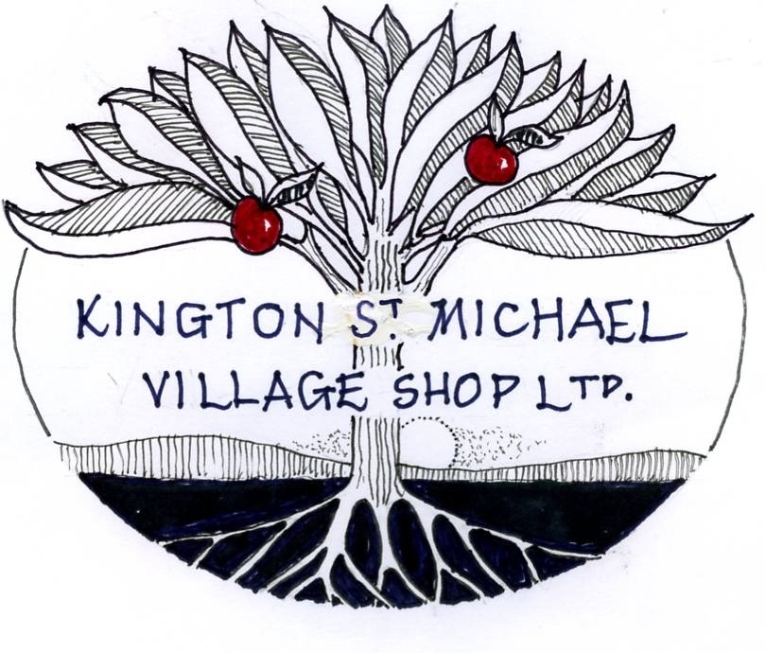

Kington St Michael Village Shop Ltd
Community Benefit Society Registration No. 30226R

*I/we wish to purchase _________ shares in
Kington St Michael Village Shop Ltd, at a cost of £5 per share.

*I/we enclose cash/cheque for £___________ made payable to
Kington St Michael Village Shop Ltd.

*I/we have made a BACS payment of £___________ in favour of
Kington St Michael Village Shop Ltd, sort code 08-92-99,
account no. 65254493

*Please delete as applicable (shareholders must be aged 16 or over)

If you pay by BACS kindly email ksmshopsecretary@yahoo.com when this has been done.

Name/s _______________________________________________________

Address _______________________________________________________

______________________________________________________________
Post code _________________________________

Email _________________________________________________________

Tel no. _____________________________________

Date _______________________________________

Signed ________________________________________________________

Please return completed form together with your cheque/cash payment, if applicable, to The Secretary c/o Kington St Michael Village Shop Ltd,
Village Hall, Kington St Michael, Chippenham, Wiltshire, SN14 6HX

